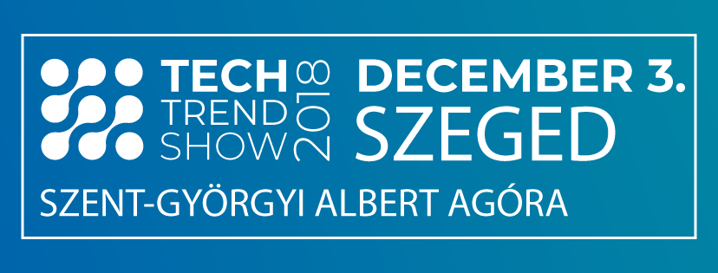

PRESENTER REGISTRATION

Given the success of last year’s event, this year the Software Innovation Pole Cluster also organizes the TECH TREND SHOW 2018 SZEGED event.
Nearly 200 visitors last year inspired the organizers to turn the event into the leading forum for mapping of new trends and their societal impact in Mobility, Electronic Payment Solutions, VR / AR / Gaming, Digital Health Care, CRM / Loyalty, E-Commerce, Online logistics and Gamification.
Take the opportunity! The event is a great platform to present your company's developments and products related to any of the above-mentioned topics before a domestic and international audience.

Focus areAs of the TECH TREND SHOW, please select
 | Select the focus areas that match your presentation | Title of presentation
- Electronic payment solutions (20-minute presentations)
- VR/AR/Gaming (20-minute presentations)
- CRM/Loyalty - E-commerce & Online logistics: Store, Pack and Ship done, Influencer marketing (20-minute presentations)
- Mobility – Self-driving – Driverless – Electro-mobility (20-minute presentations)
- Digital Health Care (20-minute presentations)
- HR and management challenges of an evolving ICT market: training, recruiting, gamification …
- (20-minute presentations)

Confirmation of intent to hold a presentation:
Contact Persons:
For the presenter:
name:
represented company
position:
telephone number:
e-mail:
tel./fax:

For the Organizer:
name: Mónika Gortva-Kónya
telephone number: +36 20 509 4629
e-mail: konya.monika@portanovum.hu
Confirmation date: 2018. …………

…………………………….. ..………………………..
Presenter Organizer

